**An Optimization Analysis about Advertising Campaign of NIKE**

TEAM MEMBER: XIAOYU ZHANG

WENZHUO LEI

XIAO WAN

XIAOZHOU YU

INSTRUCTOR:ALKIS VAZACOPOULOS

Table of Contents

Abstract 4

1 Challenge/ background descriptions 6

2 Literature review 6

2.1 Nike 6

2.2 Advertisement campaign 7

2.3 CPM 8

2.4 Exposure 8

3 Data Description 9

4 Model Development 13

5 Solution 15

5.1 Developing the Spreadsheet Model 16

5.2 Using evolutionary solver 18

6 Conclusion 19

6.1 Analysis 20

6.2 Limitation 21

6.3 Improvements 22

6.4 Generalization and Customization 23

Reference: 25

# Abstract

Our challenge is about an optimization analysis of advertising campaign of Nike. In sportswear industry, which is a pretty mature market, companies are hard to make innovative products to stand out. Many companies spend enormous amounts of money on advertising their products. They want to ensure that they are spending their money wisely. Typically, they want to reach a large number of various groups of potential customers and keep their advertising costs as low as possible. It motivates the need to create a model help the company use limited advertising budget efficiently. Though analysis, we found that there should be no more investment on Newspaper and Radio advertisement. And most of the budget is allocated to digital media(Internet) instead of traditional media channels. Besides, it is the result of relative higher CPM of digital media, which is more efficient on the non-differential spread. In addition, the magazine & TV advertisement can be beneficial by adjusting the percentage of the target audience (young customer at age 17-25).

# 1 Challenge & Background

Our challenge is about an optimization analysis of advertising campaign of Nike. When our team first discussed the optimization problems, we thought about many themes of different industries. Then we decided to focus on advertising campaign since advertising expenditure has become a significant proportion of a company. Nowadays, many companies spend enormous amounts of money on advertising their products. Apparently, they want to ensure that they are spending their money wisely. Typically, they want to reach scores of various groups of potential customers, at the same time, keep their advertising costs as low as possible. In this case, it is crucial for a company to figure out how to optimize their advertising campaign and reach their desired goal. So we want to build a model to help them modify the budget into different channels and maximum the total exposures under a limited budget.

# 2 Literature review

## 2.1 Nike

Nike is an American [multinational corporation](https://en.wikipedia.org/wiki/Multinational_corporation) that is engaged in the design, development, manufacturing and worldwide marketing and sales of footwear, apparel, equipment, accessories, and services([Nikebiz: Company Overview: History: 1960s](http://www.nikebiz.com/company_overview/history/1960s.html), Nike, Inc., Retrieved on August 12, 2010).

In sportswear industry, which is a pretty mature market, companies are hard to make innovative products to stand out. But Nike’s advertisements become better and better as time goes by, and they were named Advertiser of the year event two times. Nike's is the most valuable brand among sports businesses, and there are much powerful marketing and advertising campaign during the company's history. For example, in the late 1980s, Nike created the "Just Do It" campaign, which was a hit in all over the world. Most importantly, during last five years, they spent more than 4 billion dollars into an advertisement. So Nike is a good choice to study and be generalized to the whole sportswear industry.



Figure 1: Nike uses the "Just Do It" creative idea

## 2.2 Advertisement campaign

An advertising campaign is a group of advertisement messages that share a single idea and theme which make up an integrated marketing communication. Advertising campaigns usually use different media channels over a particular time frame and are often mandated to be rationally defined. In our project, despite the content of an advertisement campaign, we take more concentration on the media strategy. In fact, media strategy is a very significant part in a whole advertisement campaign. How to choose the marketing channels and how to divided the total advertising budget into different media channels are the most important part we are focusing with.

## 2.3 CPM

CPM means “Cost per thousand impressions." It is a term used in traditional [advertising media selection](https://en.wikipedia.org/wiki/Advertising_media_selection), as well as [online advertising](https://en.wikipedia.org/wiki/Online_advertising) and marketing related to [web traffic](https://en.wikipedia.org/wiki/Web_traffic). It refers to the cost of traditional advertising or [internet marketing](https://en.wikipedia.org/wiki/Internet_marketing) or email advertising campaigns, where advertisers pay each time an ad is displayed. It also used to assess the cost effectiveness and profitability of traditional and online advertising. CPM allows a company to compare media based on two variables: audience and cost. The lowest cost per thousand media is the most efficient while all other variables being equal.

For traditional media:

For online media:

## 2.4 Exposure

There are many solutions to measure the total effectiveness of an advertising campaign like how many people are reached, how it's resonating and consumer's reaction. This time we choose exposure as the method to evaluate the advertising effectiveness since advertising exposure is a presentation of an advertisement to the user. Usually, advertisers attempt to estimate the number of exposures necessary to achieve their objective.

# 3 Data Description

Then we'll talk about how we get and clean our data. First of all, according to the background and literature review, we roughly build a model for our project. We want to build a model for a certain company, Nike, and allocate its limited advertising budget to different channels to get as many exposures as possible, aiming to increase the coverage of advertisements. With this purpose, we need to choose appropriate channels for research, get each channels' CPM value, get a sample of audience perspective, and also, Nike's budget for advertisements.

Concerning with the literature review, we found put that in U.S., it's a tendency to spend money in Internet, TV, Magazine, Radio, Newspaper, and Outdoor. So we choose these channels in our model, hypothesizing them will also be best choices for Nike or any other company in the sportswear industry.

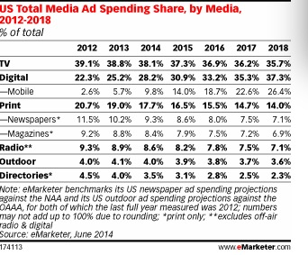

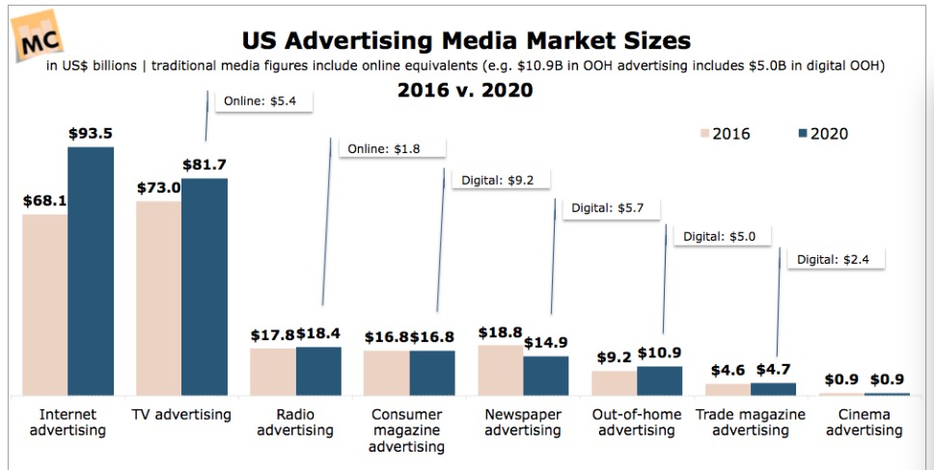

After we decided the channels, we need to find CPM value for each channel. CPM is Cost per Thousand, meaning the cost it will take the company to reach 1,000 person-times of impressions.

We get CPM value for these channels from a Morgan Stanley research, so the data is quite authoritative.

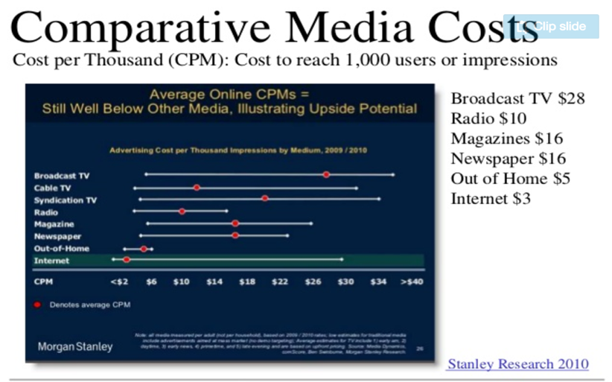

It's obvious that the lowest CPM is for the Internet, only about 3 dollars, and the highest CPM is for Broadcast TV, about 28 dollars.

According to our research, Nike targets its consumers by demographic segmentation, including age, life-cycle stage, gender, occupation, and generation. Although with apparel and sports the market can be broad, Nike primarily focuses on consumers who are between 18-27 ages. Nike caters to both male and female athletes equally and is placing an increasing focus on tweens and teens to build long-term brand loyalty.

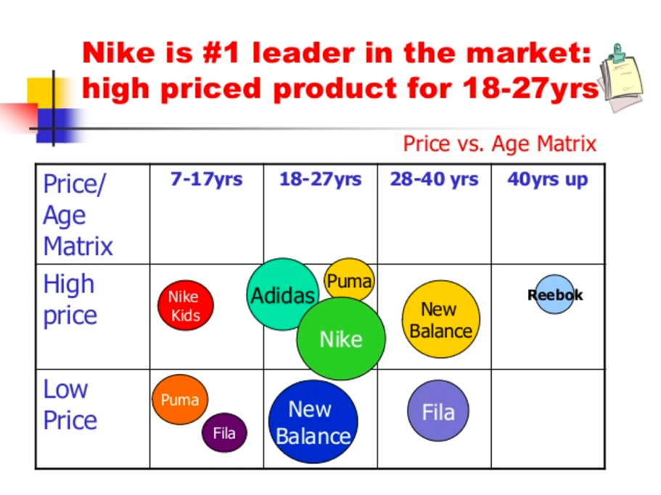

So in our model, we separate sample audience perspective data into several parts considering Nike’s target consumers based on sex and age. And we will use the proportion of audience perspective of 17-25 years old as a constraint in our model, making sure Nike can reach the desired ratio of target consumers.



Because we want to use data for 2015 in our project, so we need to find advertising expenditure for Nike in that year. However, it's too new for us to find this data. Fortunately, we find advertising expenditure for Nike from 2009 to 2014 in an authoritative website and get the bar graph shown as below, and it's clear that we can't get data of 2015.

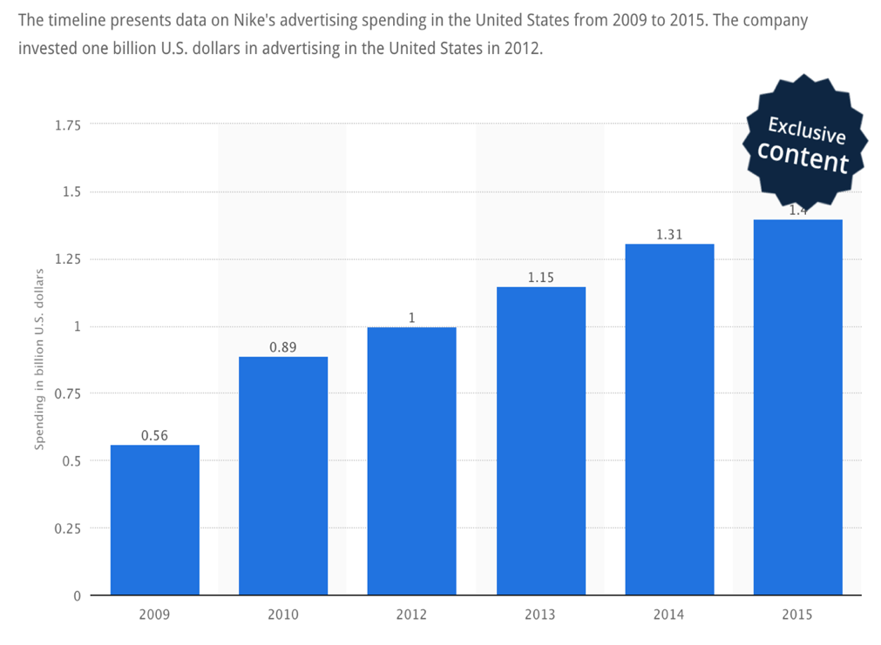

So we want to use 2009-2014 advertising expenditure data to do a regression and predict expenditure in 2015. We get the equation of:

Here y represents advertising expenditures in billion U.S. dollars and x represents the year.

And we can notice the R-square for this regression model is 0.95181, it’s quite high, meaning the regression fits pretty good, and so our prediction of advertising expenditure in 2015 is reliable.

# 4 Model Development

Nike is an American [multinational corporation](https://en.wikipedia.org/wiki/Multinational_corporation) that is engaged in the design, development, manufacturing and worldwide marketing and sales of footwear, apparel, equipment, accessories, and services. It is one of the world's largest suppliers of [athletic shoes](https://en.wikipedia.org/wiki/Athletic_shoe) and [apparel](https://en.wikipedia.org/wiki/Clothing) and a major manufacturer of [sports equipment](https://en.wikipedia.org/wiki/Sports_equipment). Being an early adopter of [internet marketing](https://en.wikipedia.org/wiki/Internet_marketing), Nike needs to set its yearly advertisement budgets for its multimedia marketing campaigns.

The total marketing budget is 158 million dollars, it needs to be allocated into six channels: newspaper, magazine, radio, TV, outdoor and Internet. The first five channels are categorized as traditional marketing channels, the last one is categorized as a new marketing channel.

Each channel has different CPM (the cost or expense incurred for every thousand potential customers who view the advertisement.). Also, the demographical coverage differs among different channels.

The overall objective is to maximize the total brand’s exposure given the marketing budget.



Constraints are listed as below:

* A lease 14% of total exposure should be female from age 17 to 25.
* At least 20% of the advertisement budget should be spent on TV channel.
* Traditional Channels (including Newspaper, Magazine, Radio, TV and Outdoor) should take up at least 50% of the total budget. 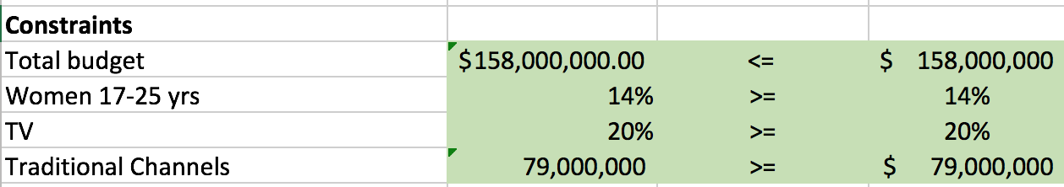

# 5 Solution

In this problem, there are two major limitations. The first one is the budget, which means all the money invested in every channel are no more than $158,000,000. The second limitation is from three constraints: the proportion of target audience (women 17-25 years old), the proportion of money invested in TV advertisement, and the proportion of money invested in digital media channel (Internet advertisement).

The data for the problem appear in the Figure 3-1. Row 7 is the CPM value of each channel. And the audience composition of each channel is given by row 12 to 21. To be noticed, the number in each column are independent. And the row 23 to 32 indicate the percentage of different audience group in one channel. For example, 5% in the cell B23 indicates that among 5% of Newspaper readers are male readers under 16 years old. And 10% in the cell C32 indicates that 10% of Magazine readers are female readers at 45 years old or above.

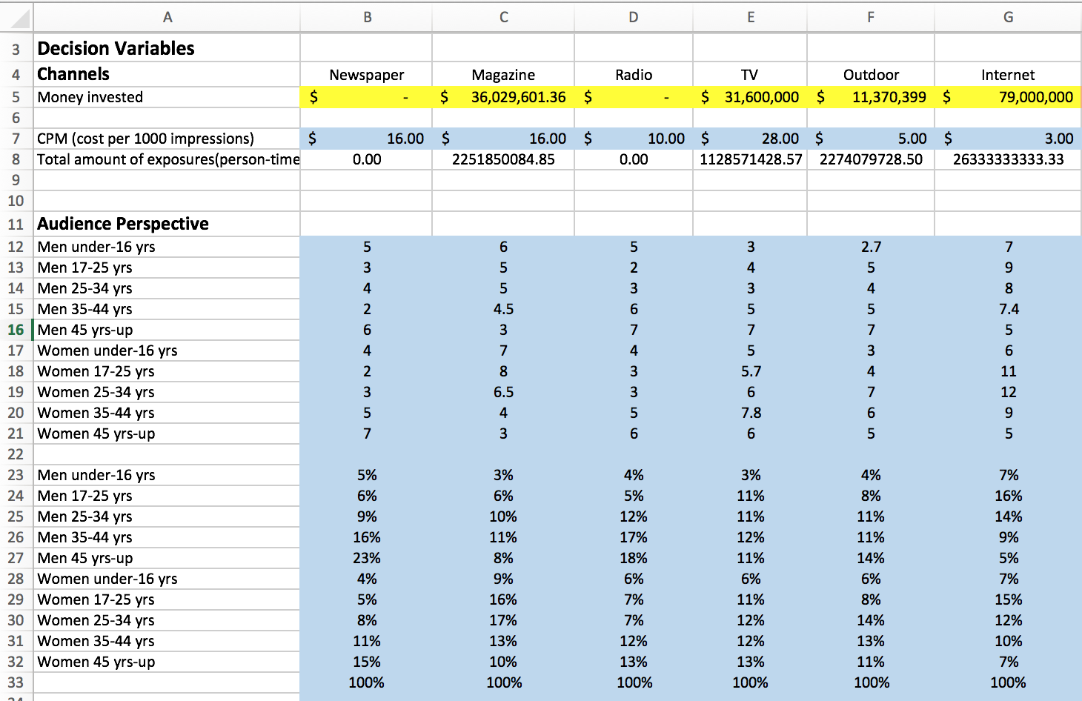

Figure 3-1 Inputs for the Advertisement Campaign Optimization Model

## 5.1 Developing the Spreadsheet Model

The completed model appears in Figure 3-2. It can be developed with the following steps:

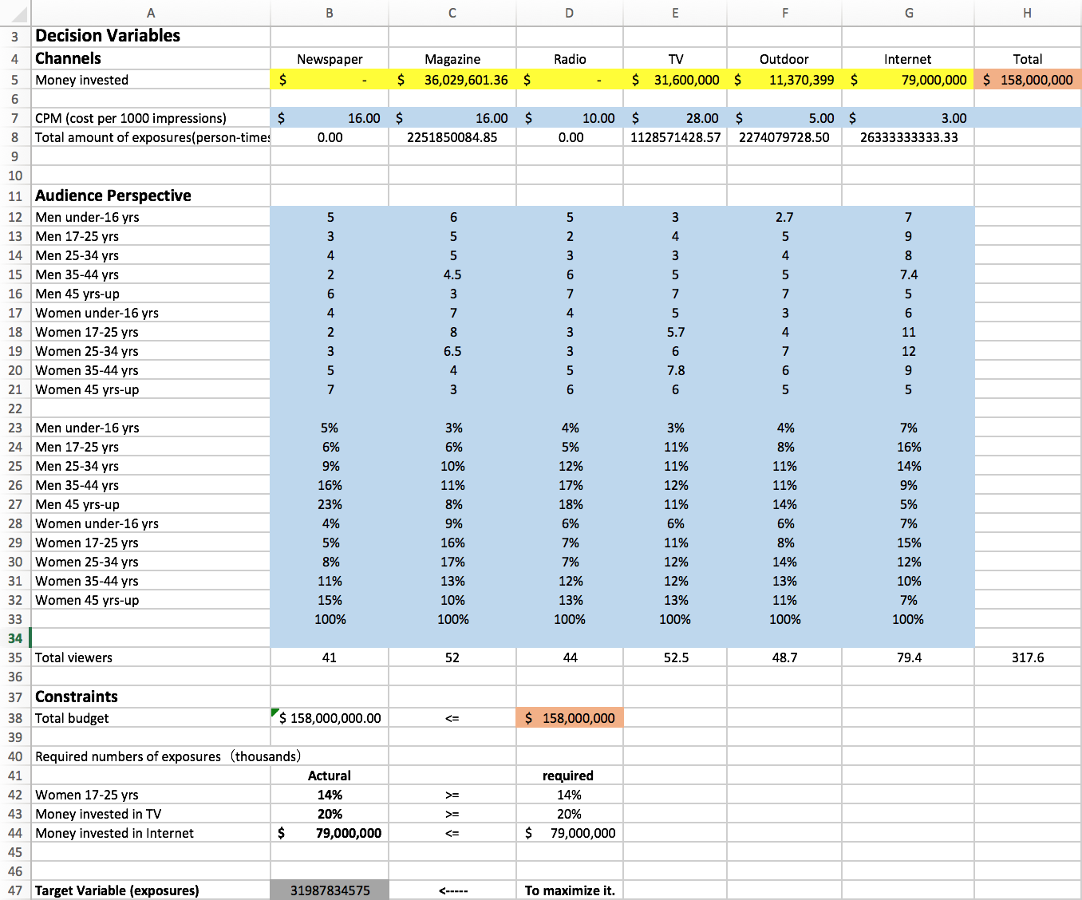

Figure 3-2 Advertisement Campaign Optimization Model

1. **Money invested in each channel.** The decision variables are the distribution of budget in each channel in terms of money investment. Enter any values for these in the Production range.
2. **The total amount of exposure (person-times) in each channel.** To calculate the amount of exposure in each channel, enter the formula

=(B5/B7) * 1000

in cell B8 for Newspaper channel, and copy it across for the other channels.

1. **Total money invested.** To calculate the total amount of money allocated to all channels, enter the formula

=SUM(B5: G5)

in cell B38. And then it can be compared with the budget limit.

1. **The actual proportion of women audience between 17-25 years old.** To see how many target audience (women 17-25 years) are reached through all the channels, enter the formula

=SUMPRODUCT(B29: G29, B8: G8)/SUM(B8: G8)

in cell B42. And then it can be compared with the target audience constraints.

1. **The actual proportion of money invested in TV channel.** To calculate the percentage of money invested in TV channel, enter the formula

=E5/B38

in cell B43. And then it can be compared with the constraints on the preference of channels.

1. **The actual proportion of money invested in Internet channel.** To calculate the percentage of money invested in Internet channel, enter the formula

=G5

in cell B44. And then it can be compared with the constraints on the preference of channels.

## 5.2 Using evolutionary solver

The Solver setup for this model appears in Figure 3-2. The objective is to maximize the total brand’s exposure, the changing cells are the marketing budget for each channel, and there are three constraints for the marketing budget allocation mentioned in set 2.1.

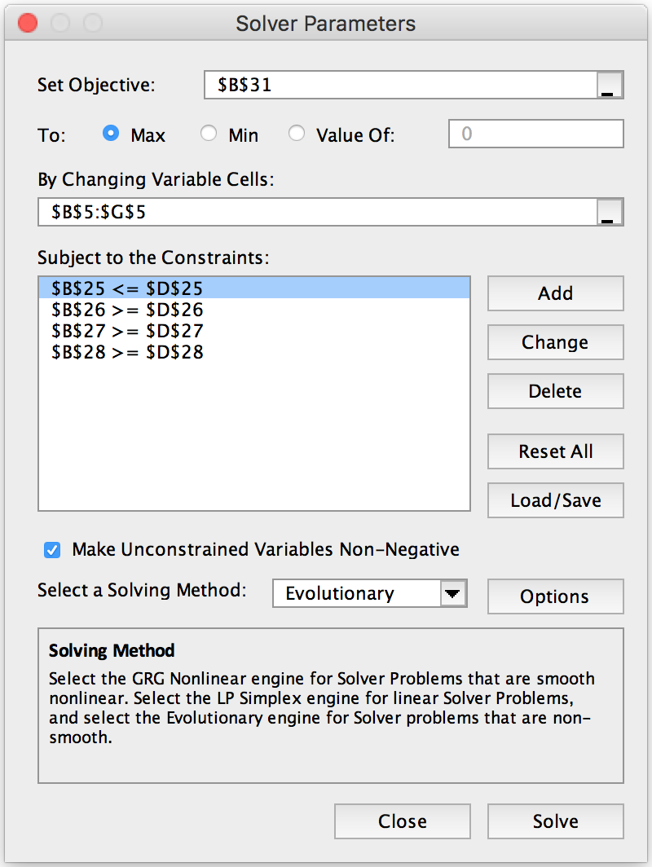

Figure 3-2 Solver setup for Advertisement Campaign Optimization Model

After some experimenting, the Evolutionary Solver finds a good solution as the one in figure 3-3.



Figure 3-3 Solutions for Advertisement Campaign Optimization Model

# 6 Conclusion

The optimal solution given by Solver is displayed by the table and graphs below.



Figure 4-1 The Optimal Solution Data

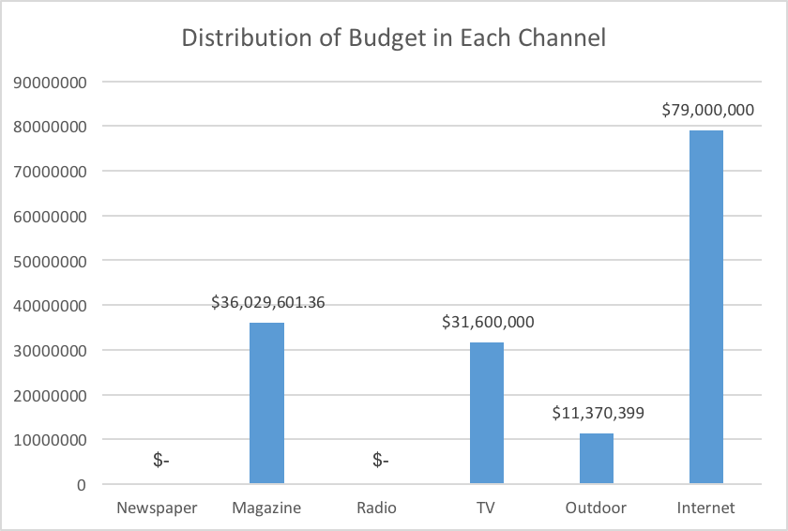

Figure 4-2 The Optimal Solution Histogram

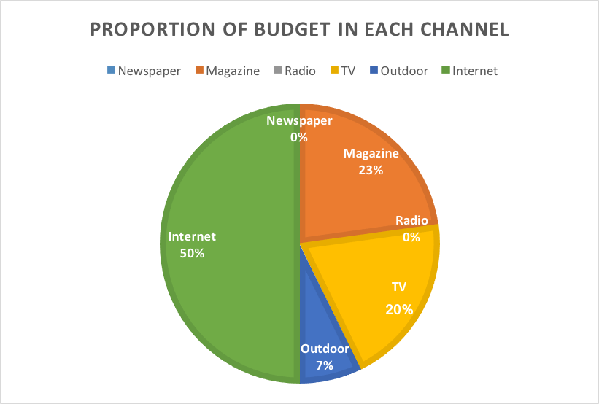

Figure 4-3 The Optimal Solution Pie Chart

## 6.1 Analysis

As showed in Figure 4-2, there should be no more investment on Newspaper and Radio advertisement. And according to Figure 4-3, near half of the budget is supposed to be allocated to digital media (Internet), which is equal to the total distribution of traditional media channels. So why is the Internet advertisement so important? Why are other traditional channels kept in the solution?

First, this preference might be the result of relatively lower CPM of digital media, which can be more efficient on non-differential popularization spread. At the same time, Magazine and TV advertisements can be beneficial by adjusting the percentage of the target audience (young women at age 17 through 25). Because female audience takes a large proportion of total audience of magazines and television advertisements.

As for the Outdoor advertisement, it may contribute in terms of diversity of media channels and audience composition. Generally, outdoor advertisements are more conspicuous and have the steady radial influence to passengers. Comparatively internet advertisement might cover less elderly people, while outdoor posters aim at all the possible audience passing by. Therefore, this special means will not be given up by companies.

## 6.2 Limitation

All though the model offers a feasible solution, we know that it has limitation too.

First, better initial data are expected. It is difficult to collect detailed information about annual advertisement budget of NIKE, and its customer composition. The actual numbers are confidential. Also, does NIKE set a goal for exposure value? If true, what is the requirement? If not, does the company have any expectation or estimation? And more accurate data of audience structure of each channel is needed to set preference constraint. These are really helpful for analysis and prediction.

Second, current CPM is an average value according to the authoritative research, which may vary in a certain range with regard to the specific media channel. Even for advertisement in one channel, the CPM can be affected by many factors. For example, for print advertisement, newspaper and flyer can be different. On the same newspaper, the space of advertisement matters –the larger the area is, the more expensive it is, and maybe more impressive. For outdoor billboards, location is significant. But for TV show commercials, time is the keystone.

Third, current target variable is the total exposures of a product, which might be over-simplified. In practical applications, a company's advertising purpose is to increase the popularity of a product, or to strengthen reputation among target group, or to improve short-time sales. There should be specialized statistical variables for further performance assessment, rather than simply a certain value of exposure or audience coverage.

## 6.3 Improvements

Given the analysis of flaws of the current model, it is not difficult to formulate practical strategies for limitation listed above.

First, try to gather more detailed information or research about the company's commercial advertisement campaign, including the budget for next year and historical expenditure record. Also, each company may have a preference of certain channels, for different channels may provide with access to different audience groups. For example, value product should choose bus station advertisement, while the high-end product may think plane video advertisement would be a better option. The selection of channels is highly related to the brand's market niche and its promotion strategies. Another aspect is the preference of audience group, which also require more accurate data or survey result.

In order to improve the model's performance, corresponding progress should be made to the CPM data and audience coverage of each channel. As mentioned before, current CPM can not precisely inflict the input-output ratio of every channel, for the CPM is an average value. And the more authoritative search of the proportion of audience in each channel is required for better prediction.

For further consideration, maybe the subdivision of channels can benefit the performance of solver model a lot. Nowadays more and more companies begin to pay attention to precision marketing. If the target customer group has been decided, the most efficient method is to advertise just in front of their eyes. This can be achieved by choosing corresponding sub-channels. Take TV commercials for illustration, it is better to arrange kitchen supplies commercials before soap opera instead of live sports events. On the contrary, sports events are more suitable for sports brand such as NIKE. In this way, the limited budget can be expended more skillful.

As mentioned in the limitation section, the better evaluation function is needed. Instead of simply setting and reaching a goal value of exposure, we want to reflect the breadth and depth of effective impression, which means more attention should be put on the quality of advertisement rather than quantity of it.

## 6.4 Generalization and Customization

If one wants to apply this model to another company in another industry with another promotion strategy, there are some practical suggestions.

The first and simplest one are to adjust constraints for certain goal. Such as tuning the proportion of target audience and preferred channels, which can be applied to the current model without many changes.

The second one is to add constraints for a specific product. For example, we can take customers' purchasing power into consideration. The luxury brand will definitely not spend the budget on bus station posters and may set higher preference weight on the audience with higher purchasing power. Similarly, some companies may focus on customer's profession, such as whiteboard makers to school consumers. And some national enterprises might happen to promote regional sales of a certain product in inventory, then they are more likely to care about customers' location rather than their age.

The third one is to prepare different plans for different aims. For a company with different commercial advertising goals, it should build corresponding models separately instead of stick to one general model. Sometimes there are conflicting requirements. For example, in order to promote sales, it might be effective to raise the percentage of the target audience in total exposure. But this strategy is not suitable if we also want to strengthen brand reputation among potential customers. Therefore, different advertisement plans should be formulated for distinct targets.

In this way, current model can be transformed correspondingly to realize customization for different companies in different development stages in different fields.

# Reference:

1. [Nikebiz: Company Overview: History: 1960s](http://www.nikebiz.com/company_overview/history/1960s.html), Nike, Inc., Retrieved on August 12, 2010.
2. Belch, George, and Belch, Michael, eds. 2004. Advertising and Promotion: an integrated marketing communications perspective. MacGraw-Hill/Irwin.
3. All business Editors: in advertising, Marketing&PR. [What Is CPM-Based Web Advertising?](http://www.allbusiness.com/marketing/advertising-internet-advertising/2646-1.html) Retrieved on December 16, 2016.

Amie Martin: [The Definition of Advertising Exposure | Chron.com](https://www.google.com/url?sa=t&rct=j&q=&esrc=s&source=web&cd=2&cad=rja&uact=8&ved=0ahUKEwiIyoGloPnQAhWHZCYKHVSOC00QFggcMAE&url=http%3A%2F%2Fsmallbusiness.chron.com%2Fdefinition-advertising-exposure-20457.html&usg=AFQjCNFVbnT5-UCRwq_dEK1HTPFFd2hlJg&sig2=wuIsU6qpKcdpRRY9wnRzcw). Retrieved on December 16, 2016.